**NAME:FAIZAN BASHEER**

**ROLL NO:24K0571**

**LAB 3 TASK**

**1.EXPLAIN THE OUTPUT OF THIS C PROGRAM.WHY IS WRONG VALUE BEING DISPLAYED?**

**THIS PROGRAMS WILL DISPLAY WRONG VALUE BECAUSE INTEGER DATA TYPE CANNOT STORE VALUES ABOVE 2147483647.WE NEED TO STORE VALUE IN LONG LONG INTEGER DATA TYPE.**

**CORRECT PROGRAM:**

**#include<stdio.h>**

**int main()**

**{**

**long long int testInteger = -2200000000;**

**printf("NUMBER IS:%lld",testInteger);**

**}**

**OUTPUT:**

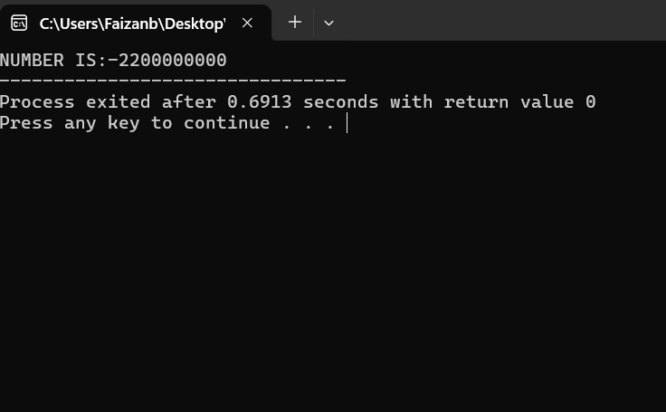

**2.FIND THE LARGEST OF 3 NUMBERS**

**CODE:**

**#include<stdio.h>**

**int main()**

**{**

**int a,b,c;**

**printf("ENTER THREE NUMBERS:\n");**

**scanf("%d %d %d",&a,&b,&c);**

**if(a>b && a>c)**

**printf("THE LARGEST NUMBER IS:%d\n",a);**

**else if(a<b && b>c)**

**printf("THE LARGEST NUMBER IS:%d\n",b);**

**else if(c>b && a<c)**

**printf("THE LARGEST NUMBER IS:%d\n",c);**

**else if(a==b && a==c)**

**printf("ALL NUMBERS ARE EQIAL");**

**else**

**printf(“INVALID NUMBERS”);**

**}**

**OUTPUT:**

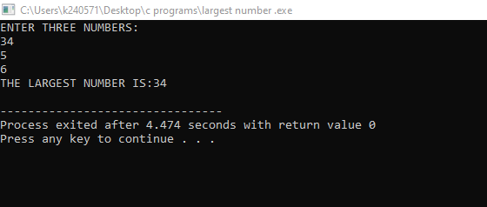

**3.A TRAVEL AGENCY ASKS YOU TO DEVELOP A PROGRAM IN C THAT CAN CONVERTY AN AMOUNT FROM ONE CURRENCY TO ANOTHER.THE USER SHOULD INPUT THE AMOUNT IN LOCAL CURRENCY AND THE CONVERSION SHOULD TAKE PLACE IN DESIRED CURRENCY.THE PROGRAM THEN SHOULD OUTPUT THE EQUIVALENT AMOUNT IS FOREIGN CURRENCY**

**CODE:**

**#include<stdio.h>**

**int main()**

**{**

**float amount,con_amount;**

**int choice;**

**printf("1.USD TO PKR \n2.PKR TO USD\n");**

**scanf("%d",&choice);**

**if(choice==1)**

**{**

**printf("ENTER THE AMOUNT IN USD:");**

**scanf("%f",&amount);**

**con_amount = amount*290;**

**printf("AMOUNT IN PKR:%f",con_amount);**

**}**

**else if(choice==2)**

**{**

**printf("ENTER THE AMOUNT IN PKR:");**

**scanf("%f",&amount);**

**con_amount = amount/290;**

**printf("AMOUNT IN USD:%f",con_amount);**

**}**

**else**

**printf("INVALID CHOICE");**

**}**

**OUTPUT:**

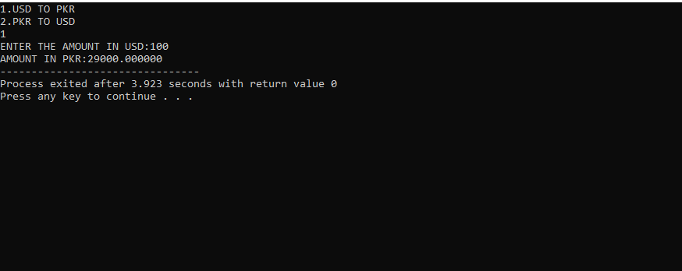

**4.FIND WHETHER GIVEN NUMBER IS ODD OR EVEN**

**CODE:**

**#include<stdio.h>**

**int main()**

**{**

**int n;**

**printf("ENTER A NUMBER:");**

**scanf("%d",&n);**

**if(n%2==0)**

**printf("IT IS A EVEN NUMBER");**

**else**

**printf("ITS ODD NUMBER");**

**}**

**OUTPUT:**

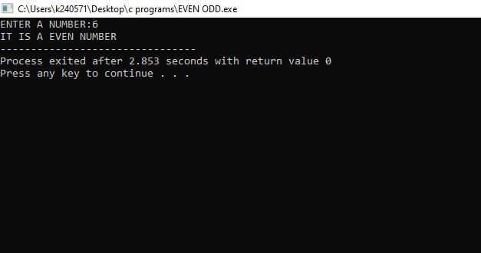

**5.WRITE C PROGRAM TO CALCULATE DISCOUNT PRICE OF ITEM PRICE RANGE BETWEEN 100 TO 50K AND DISCOUNT RATE IS BETWEEN 5% TO 30%.CALCULATE FINAL PRICE AFTER APPLYING THE DISCOUNT.VALIDATE INPUTS AND PROVIDE ERROR MESSAGES.**

**CODE:**

**#include<stdio.h>**

**int main()**

**{**

**float org_price,final_price,discount_rate;**

**printf("ENTER THE ORIGINAL PRICE BETWEEN(100 TO 50,000):");**

**scanf("%f",&org_price);**

**if(org_price<100 ||org_price>50000)**

**{**

**printf("INVALID PRICE");**

**return 0;**

**}**

**printf("\nENTER THE DISCOUNT RATE BETWEEN (5% TO 30%):");**

**scanf("%f",&discount_rate);**

**if(discount_rate<5 || discount_rate>30)**

**{**

**printf("DISCOUNT IS INVALID\n");**

**return 0;**

**}**

**else**

**final_price = org_price * (1-discount_rate/100);**

**printf("THE FINAL PRICE IS:%.3f",final_price);**

**}**

**OUTPUT:**

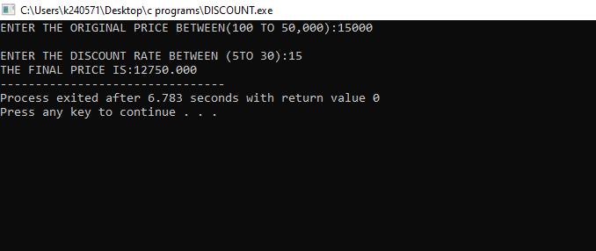

**6.FIND THE VOLUME OF CYLINDER USING FORMULA πR*R.TAKE INPUT OF HEIGHT AND RADIUS.**

**#include<stdio.h>**

**int main()**

**CODE:**

**{**

**float r,h,v;**

**printf("ENTER THE RADIUS AND HEIGTH OF CYLINDER:\n");**

**scanf("%f %f",&h,&r);**

**v = 3.141* r*r*h;**

**printf("THE VOLUME OF CYLINDER IS:%.3f",v);**

**OUTPUT**

**}**

